It’s a Boy!

John Phillip Wiggs
Baby Registry

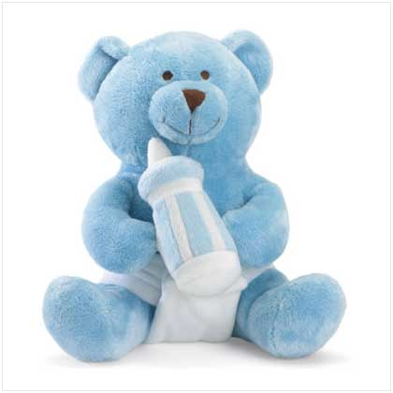
-------------------------Introduction---------------------------------

First and foremost, we want to thank everyone for the friendship and support received.

Should you wish to offer a gift, we have attempted to make the selection process easier. We have created an online registry that is NOT store specific. This gives us the freedom to identify the exact items desired that are available online or at your nearest store.

The registry we created will hopefully:
- Give better item description
- Enable purchase at the lowest cost
- Facilitate most convenient purchase method
- Prevent duplicate gifts

Each item has been researched to be safe, compatible with our lifestyle, and of superior performance in its category.

Thank you again!

-------------------------Viewing the list----------------------------

Think of this list as a shopping list. It has nothing to do with where you choose to actually buy the item.

Visit www.nwiggs.com and click on the ”Baby Registry” link to view the current list that reflects what is available and what has been purchased.

You can tell an item is available when it has the following button:

You can tell someone else has purchased the item when it has the following box instead:

Note: If you click on an item picture or title, it will take you to a merchant’s site where the item may be purchased online. This is only for your convenience and to provide more information on the item – it is not necessary to buy from that merchant. (Although feel free to buy from that site if you wish to do so.)

------------------------Buying an Item--------------------------

If you wish to purchase a certain item, please visit the online list and click the “Mark this item as purchased” button:

Once you click that link, it will ask you for the quantity purchased, and then you click the “Purchase” button.

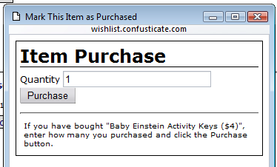

Once you have clicked the “Purchase” button the item is listed as purchased so others will know not to buy the item. You can tell by the original “Mark this item as purchased” button changing to an “This item is already purchased” button:

Feel free to mark items as purchased before you actually buy them. That way you can reserve the item long in advance and visit the store or online merchant at a time that is convenient to you.

------------------------Printing the list------------------------------

Unfortunately the only way to print the list with pictures is via a special document we have created for you.

- A copy is attached to this booklet

- An additional electronic/printable copy is available at www.nwiggs.com by clicking on the “Printable Version” link.

Note: The printed version of the list does not reflect what has already been purchased.

---------Changing your mind / Undoing a purchase--------

It is easy to change your mind and mark an item as available again. Just click on the word “here” in the sentence for that item below the grey already purchased box:
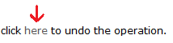

Then just click the grey “Oops” button and you’re done.

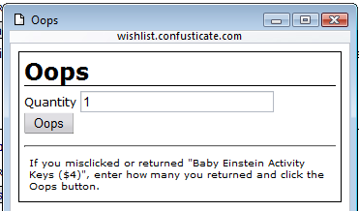

Registry (Page 1 of 12)

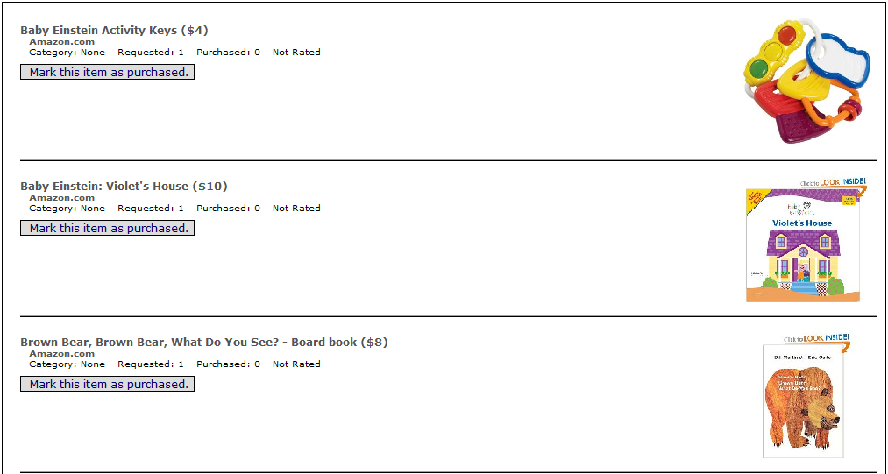
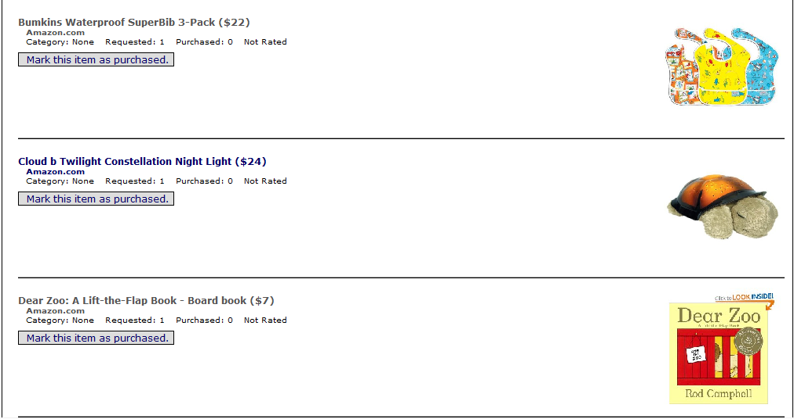
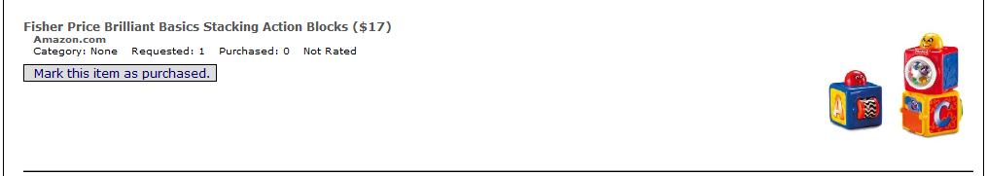

Registry (Page 1 of 12)
Registry (Page 2 of 12)

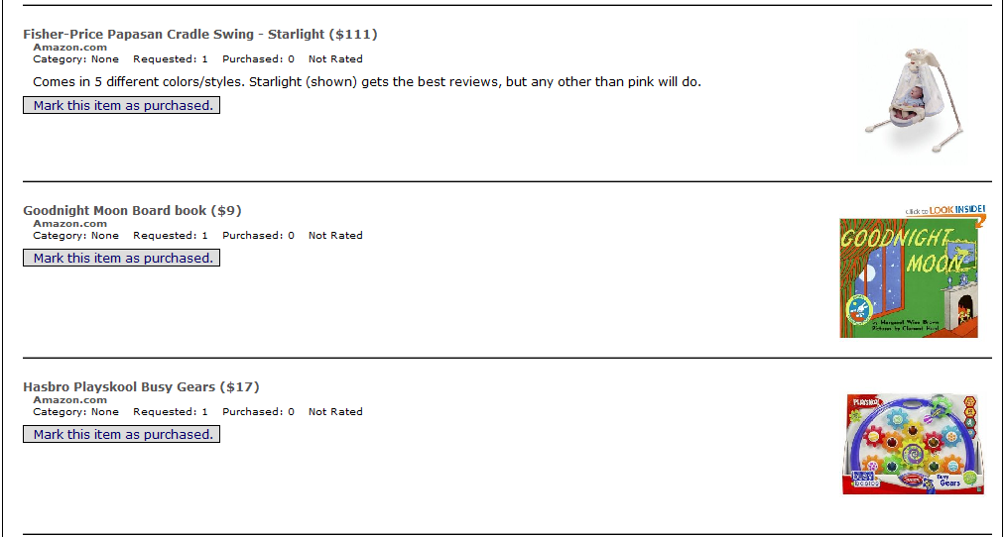
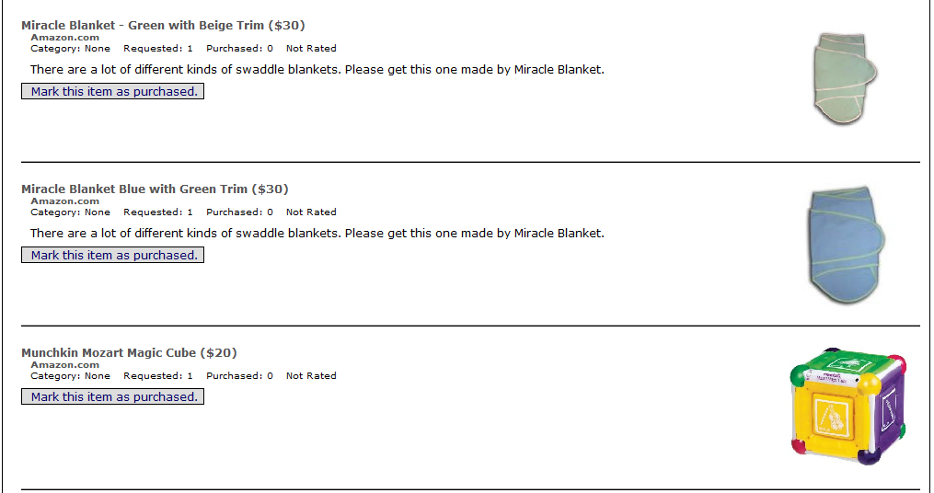
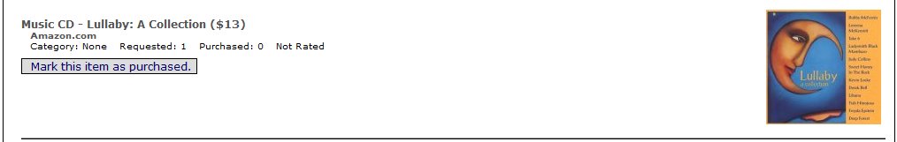

Registry (Page 2 of 12)
Registry (Page 3 of 12)

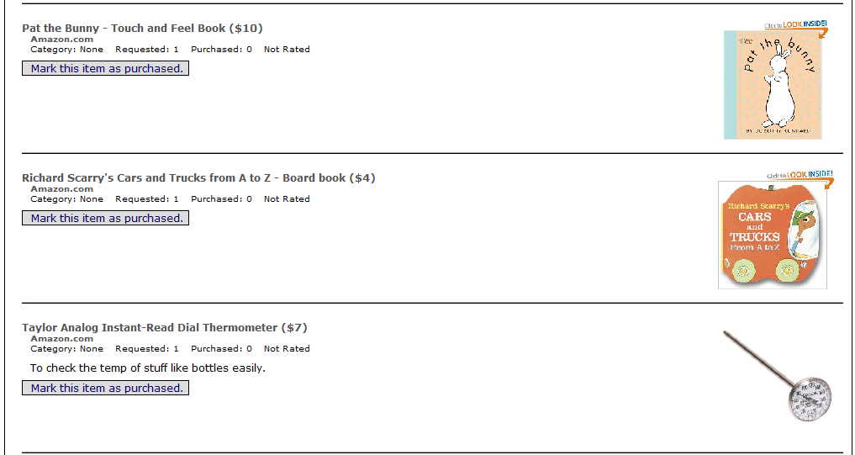
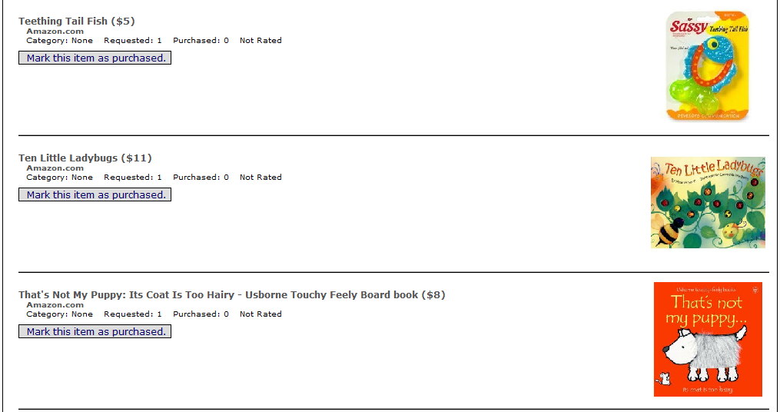
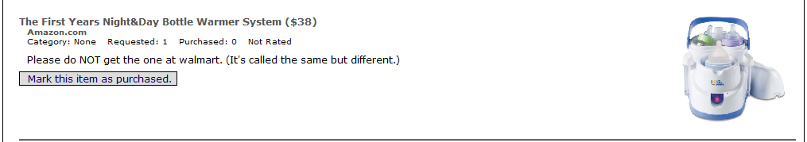

Registry (Page 3 of 12)
Registry (Page 4 of 12)

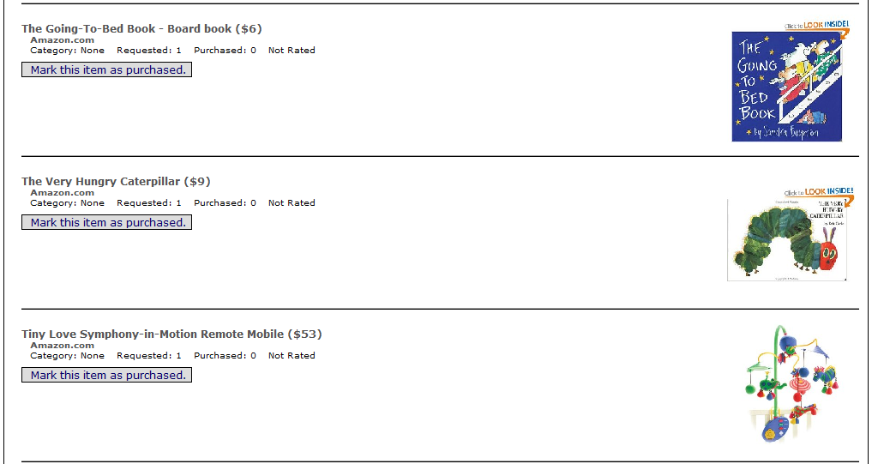
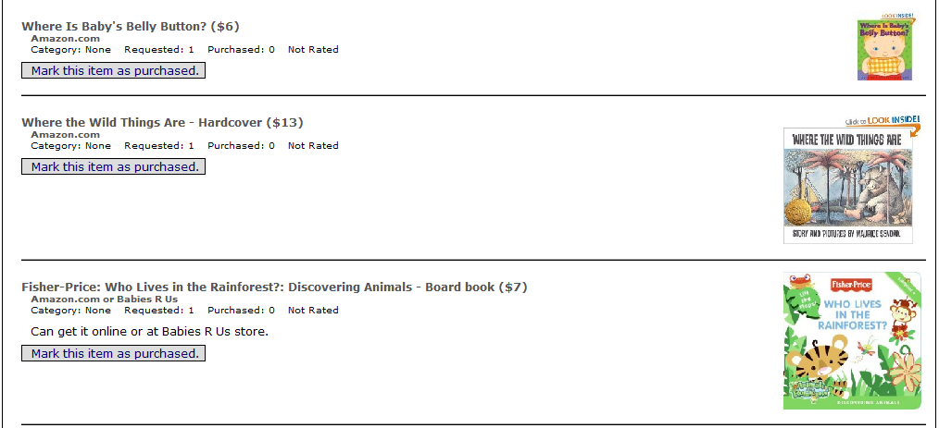
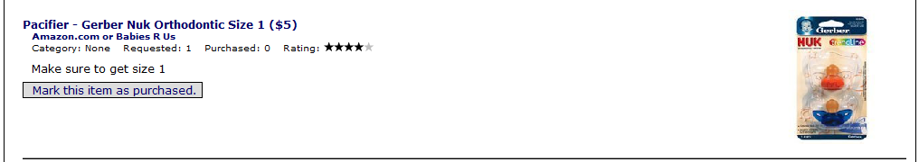

Registry (Page 4 of 12)
Registry (Page 5 of 12)

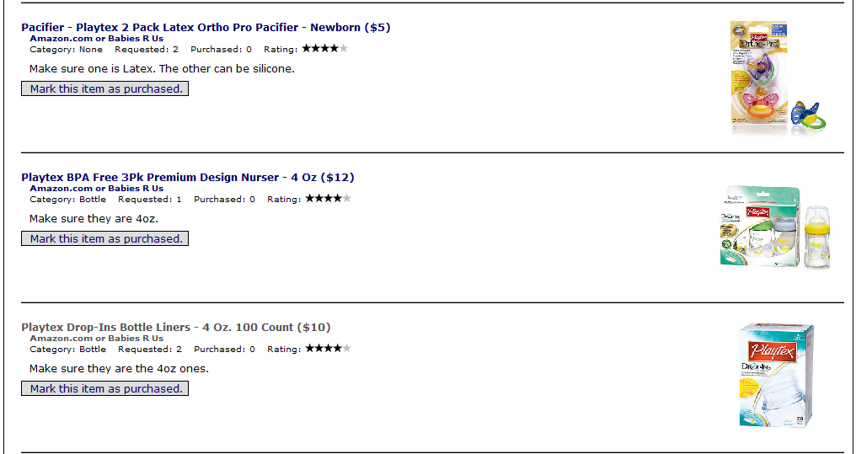
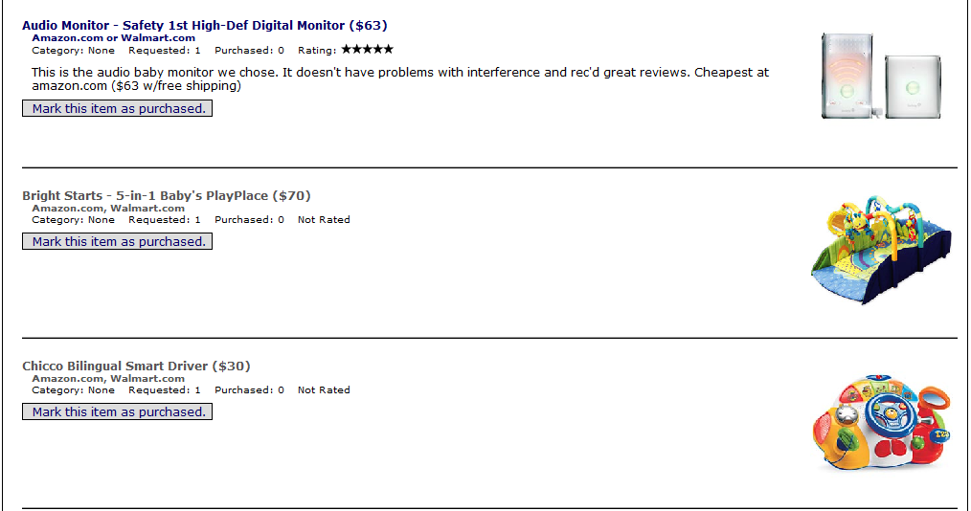
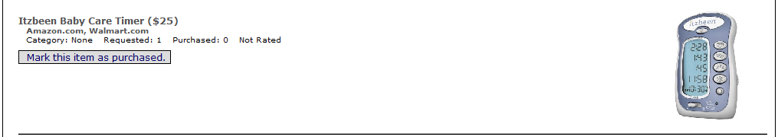

Registry (Page 5 of 12)
Registry (Page 6 of 12)

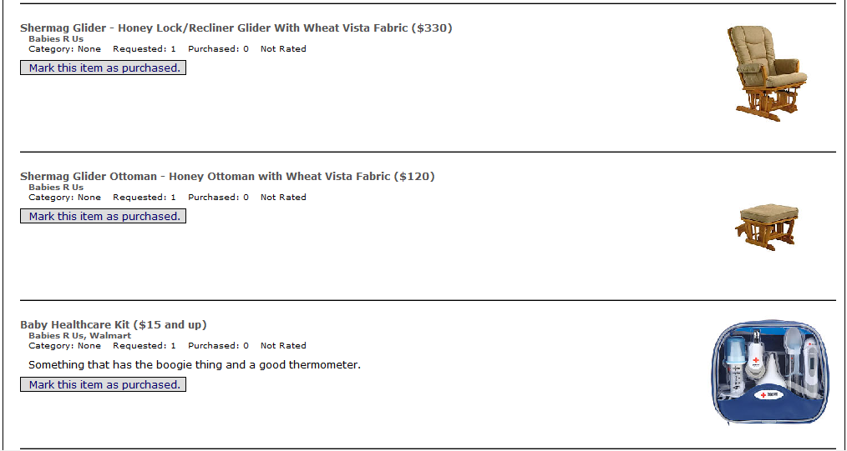
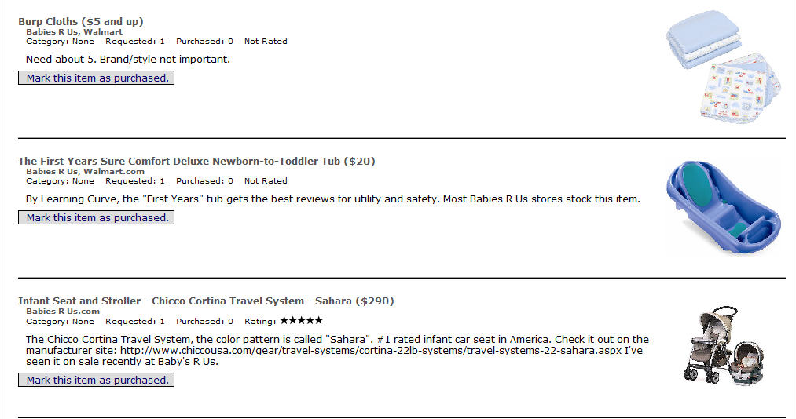
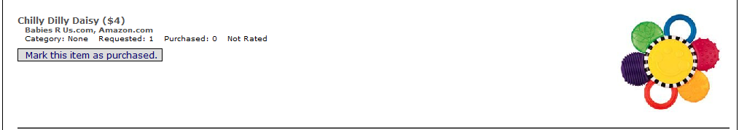

Registry (Page 6 of 12)
Registry (Page 7 of 12)

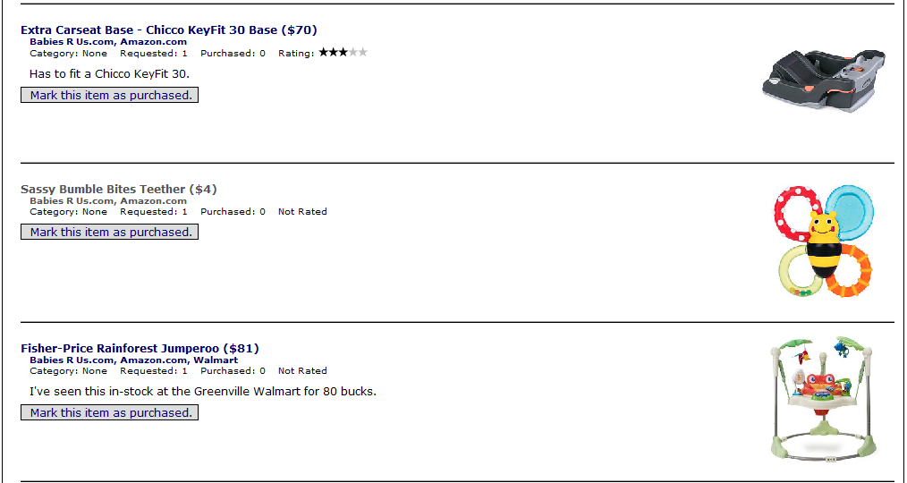
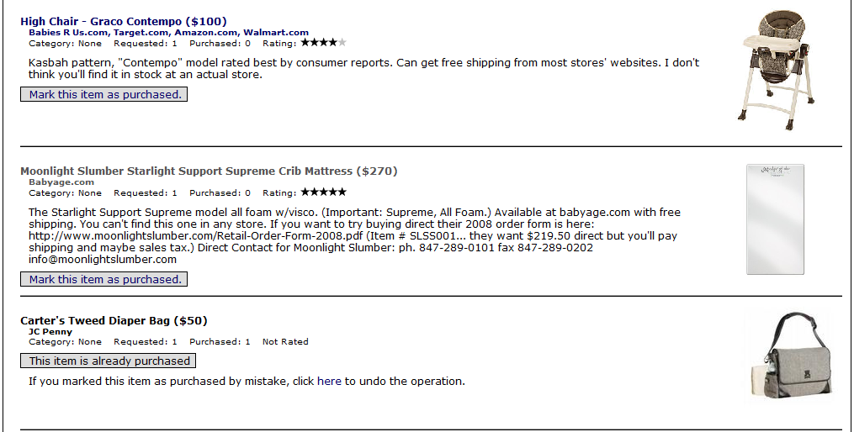
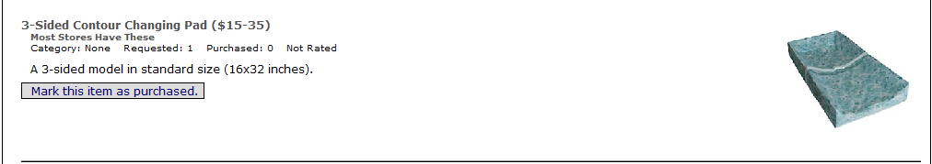

Registry (Page 7 of 12)
Registry (Page 8 of 12)

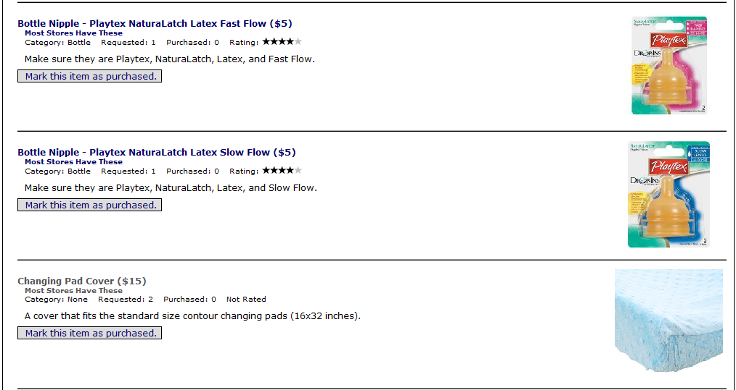
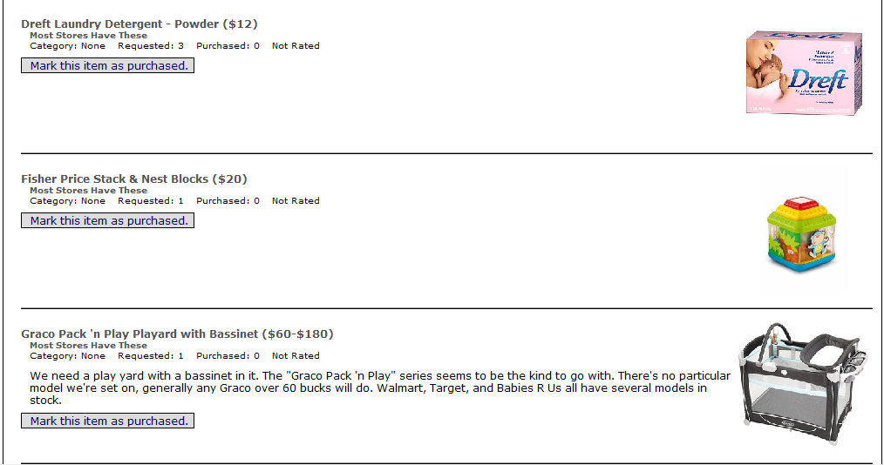
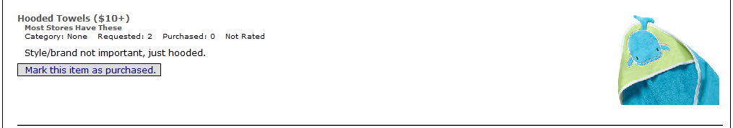

Registry (Page 8 of 12)
Registry (Page 9 of 12)

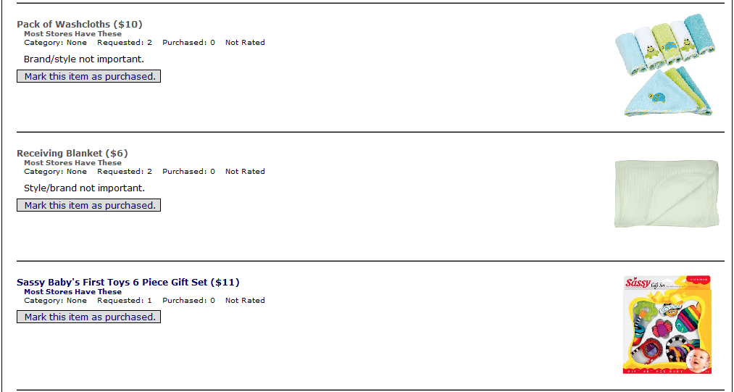
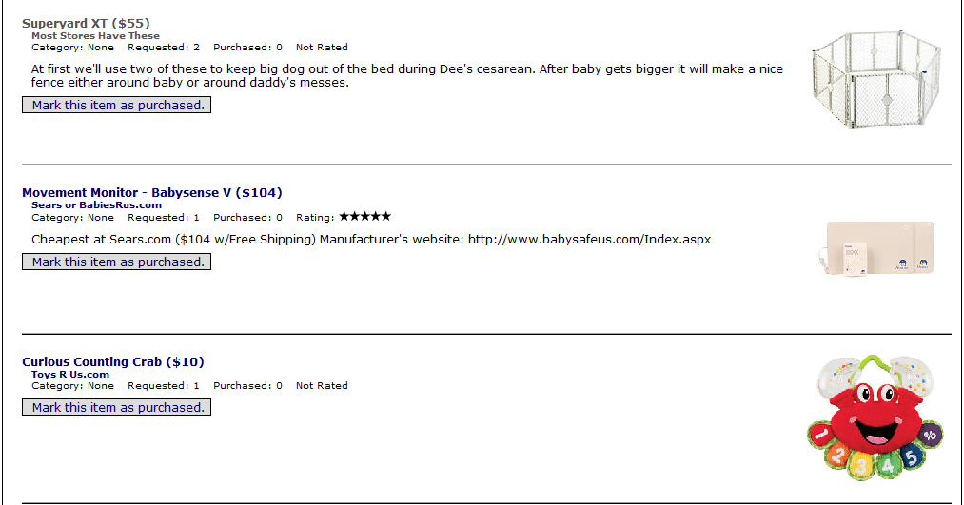
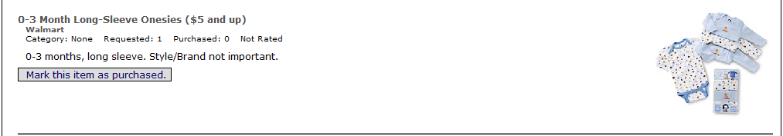

Registry (Page 9 of 12)
Registry (Page 10 of 12)

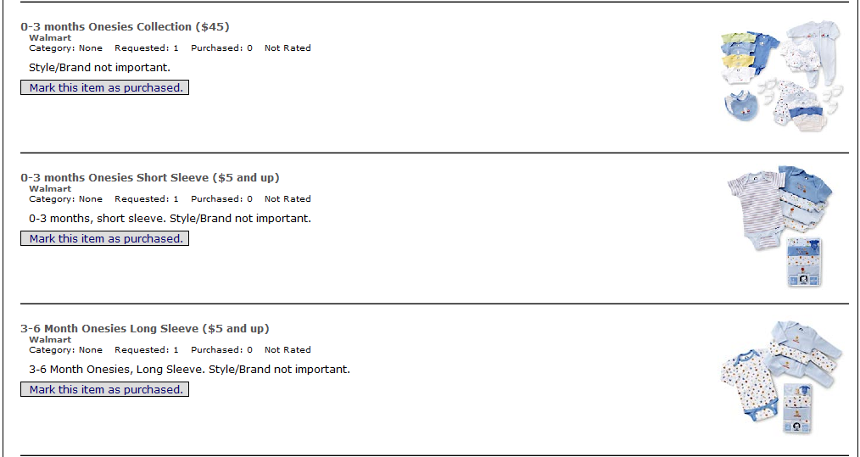
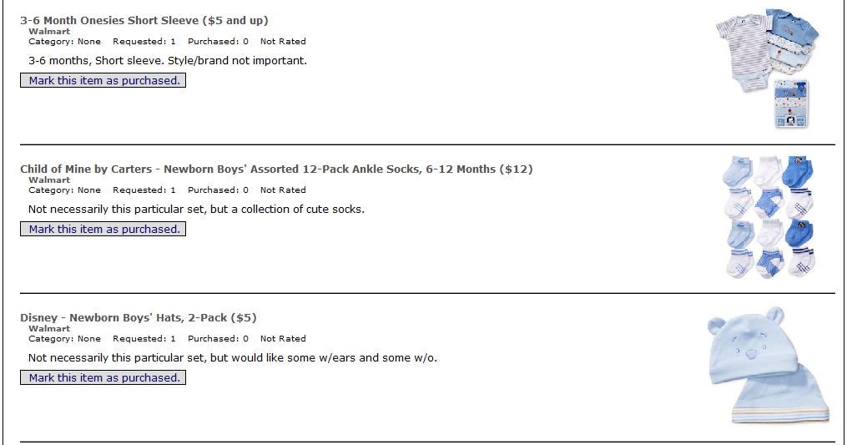
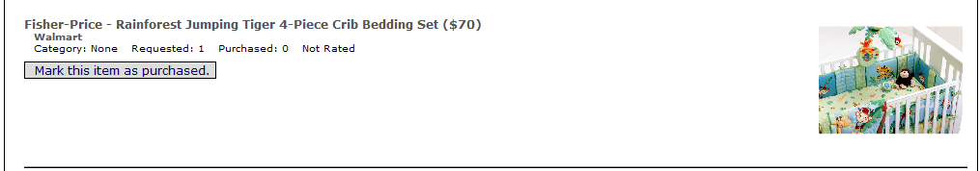

Registry (Page 10 of 12)
Registry (Page 11 of 12)

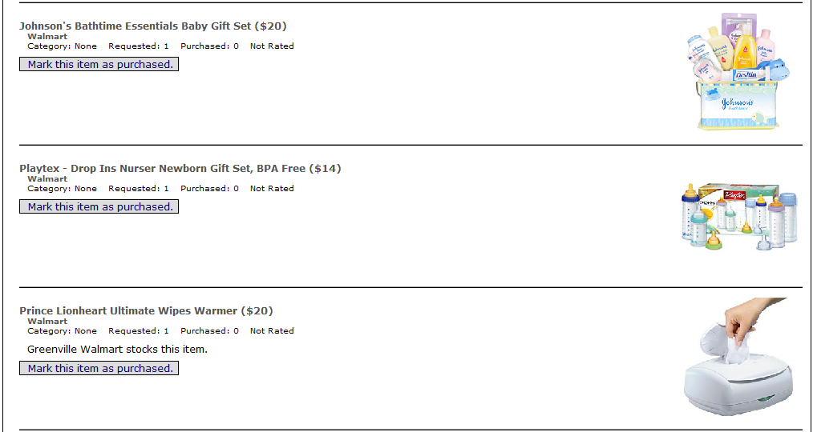
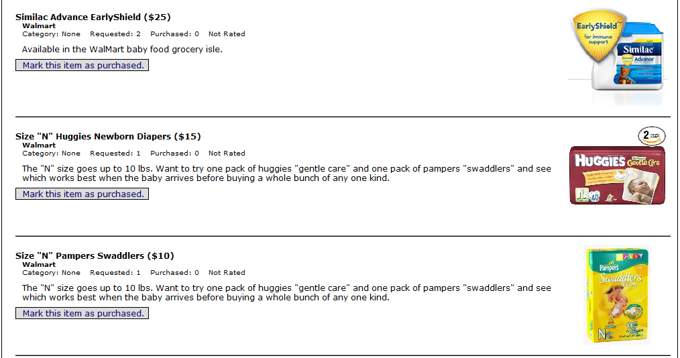
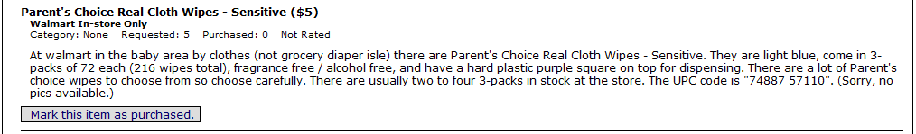

Registry (Page 11 of 12)
Registry (Page 12 of 12)

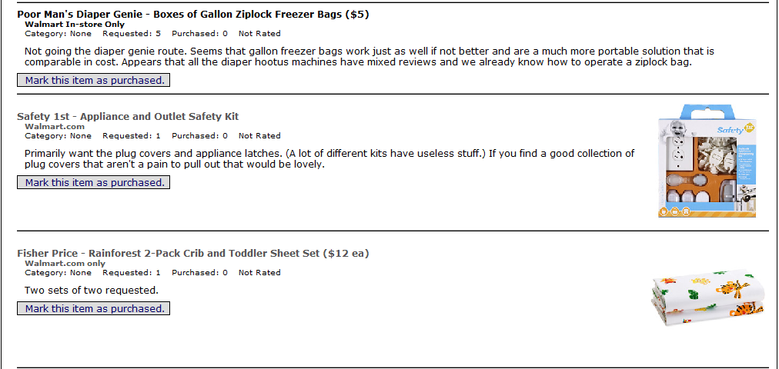
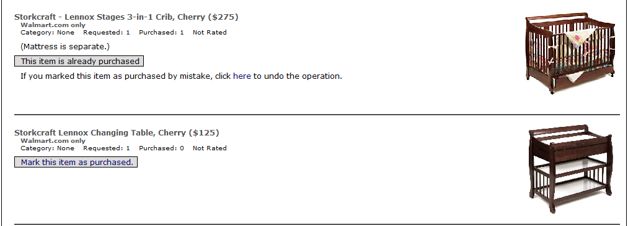

Registry (Page 12 of 12)

